Lab 4 informatics screenshots. Akkushimov Viktor

A

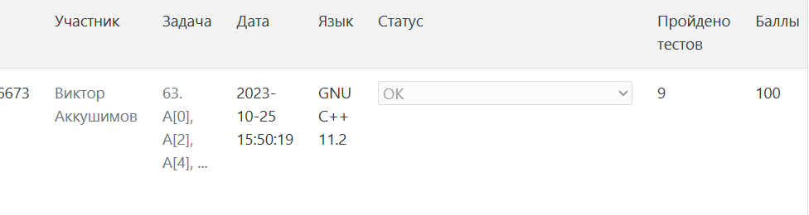

D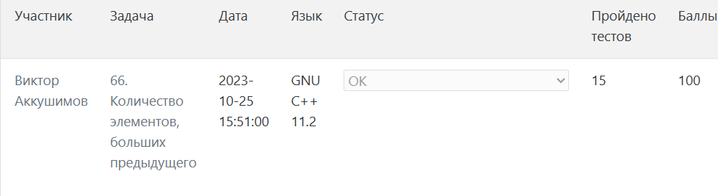

G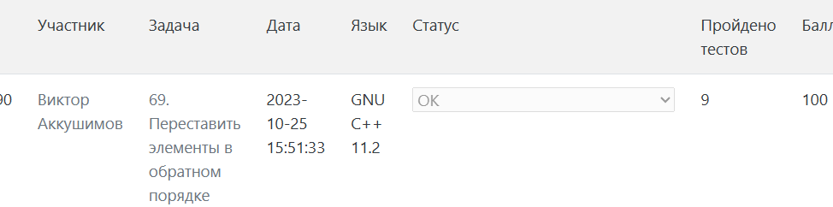

H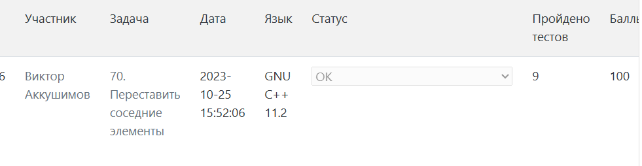

I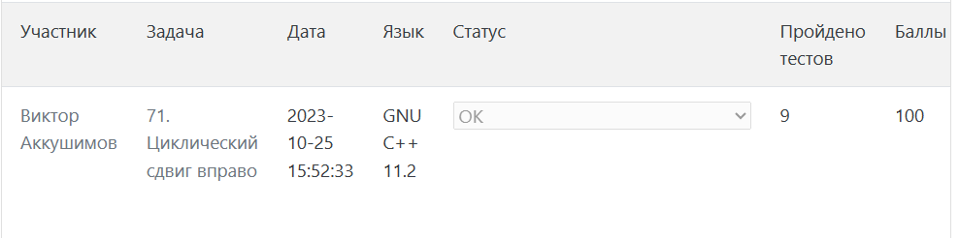

L